What is Middleware?
- A middleware is a component that:
  - Handles HTTP requests
  - Can modify request/response
  - Can short-circuit the pipeline
- Middleware executes in the order it is registered
- Each middleware decides whether to:
  - Pass request to next middleware
  - Return response immediately

Middleware Pipeline Flow
Request → Middleware 1 → Middleware 2 → Middleware 3 → Endpoint
Response ← Middleware 1 ← Middleware 2 ← Middleware 3
Built-in Middleware
ASP.NET Core provides many built-in middleware:
Common Built-in Middleware
- Exception Handling
UseExceptionHandler
UseDeveloperExceptionPage
- HTTPS Redirection
  - UseHttpsRedirection
- Static Files
  - UseStaticFiles
- Routing
  - UseRouting
- CORS
  - UseCors
- Authentication
  - UseAuthentication
- Authorization
  - UseAuthorization
- Endpoints
  - MapControllers
Custom Middleware
Custom middleware is used for:
- Logging
- Request/Response tracking
- Validation
- Performance monitoring
- Custom security rules
Creating Custom Middleware
1️⃣ Create a middleware class
2️⃣ Implement Invoke or InvokeAsync
3️⃣ Register it in the pipeline
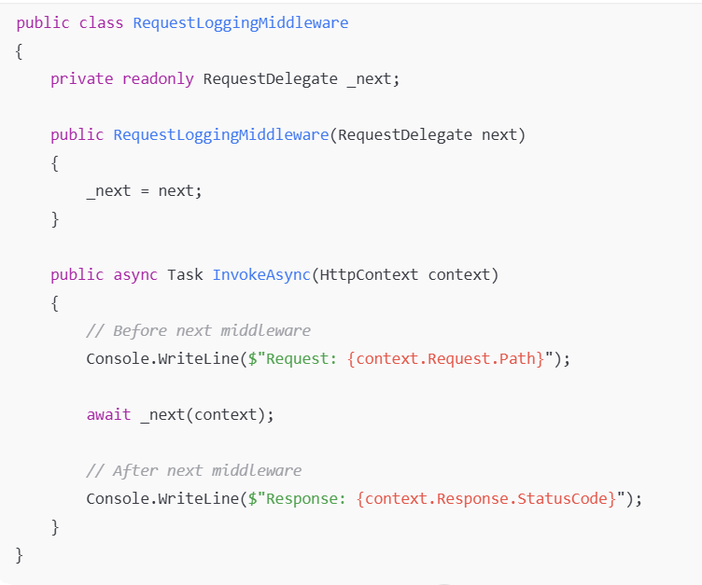
Register Custom Middleware
app.UseMiddleware<RequestLoggingMiddleware>();

